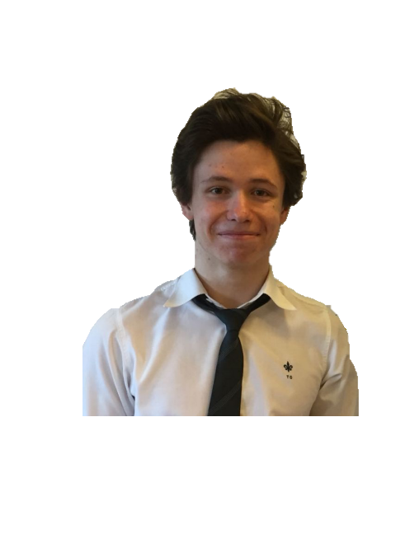

A person with a wide curiosity about scientific issues , with a desire to make great discoveries in fields of Mathematics and Computing and eager to find out the rules that govern modern living

**Bellido Pazos**

**Trilogy Group**

**Polytechnic University of Madrid**

**Trinity College San Sebastián de los Reyes**

**EXPERIENCE**

**PROFILE**

**Fernando**

**EDUCATION**

2010 - 2018

Tech support trainee and web developer at Trilogy Group

2018

Degree in Mathematics and Computer Science at Madrid´s Polytechnic

Primary, secondary and science baccalaureate education

(+34) 638907402

2018 - Today

<https://fbellidopazos.github.io>

Spanish

English

**IDIOMAS**

2017-2018

**Trinity College San Sebastián de los Reyes**

Teacher trainee

Programming teacher for 3 months.

**AWARDS**

## Cambridge English level: Advanced Certificate (C1)

Cambridge English: First, also known as Advanced Certificate (FCE) is a high degree. It shows that I can use every day English both written and spoken for work or educational purposes.

Santo Domingo, Algete, Madrid, 28120

[fbellidopazos@gmail.com](mailto:fbellidopazos@gmail.com)